**Project 2:**

**Contributor: Preetham Wilfred John**

**ID : 1603525**

**Programming Language : C#**

**Synopsis:**

The Server program starts execution and waits for clients to get connected.

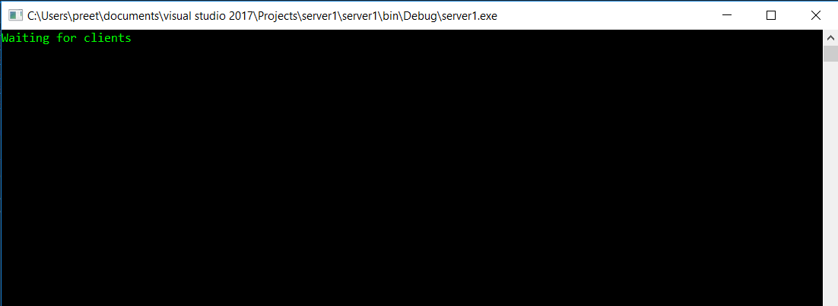

So simultaneously clients need to start executing and establish a connection with the server by entering the server IP address.

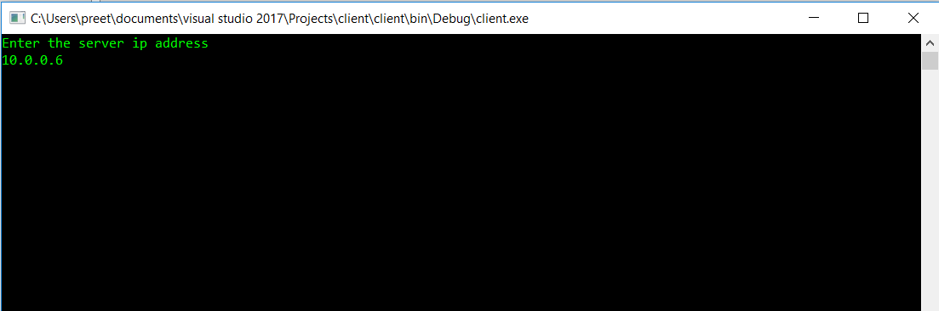

Once the connection is established the client needs to identify itself to the server by specifying its ID(1/2/3/4)

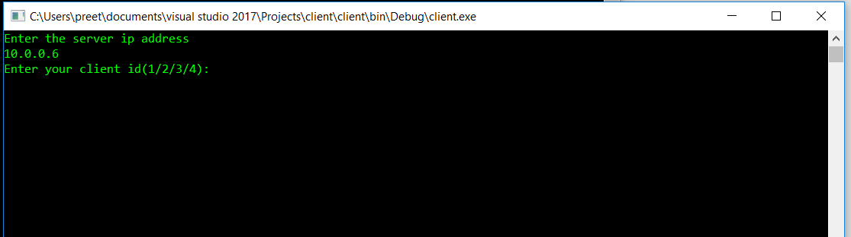

Based on the client the server will start a separate thread for each client.

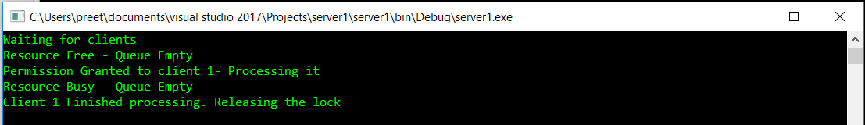

Client will first begin executing outside non critical section

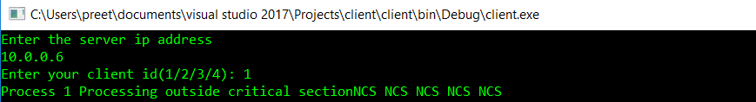After it gains access over the shared resource in server it will start accessing the critical section.

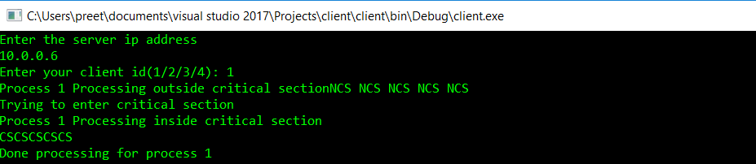

Similarly the other clients access the shared resource if it is free else it will wait for the shared resource to get freed up